  

YOUR RIGHT

TO KNOW

DHAKA WEDNESDAY JUNE 5, 2024

Regd. No. DA 781 Vol. XXXIV No. 136 Jaishtha 22, 1431 [www.thedailystar.net](http://www.thedailystar.net) BS 20 Pages : Tk 15.0

bs

Power, agriculture to

drive up subsidies

Djokovic out of French Open with injury

P6

Our forests are disappearing when we need them most

P7

South Africa’s ANG weighs up partners after polls

P10

Plastic Pollution invades the Sundarbans

P11

    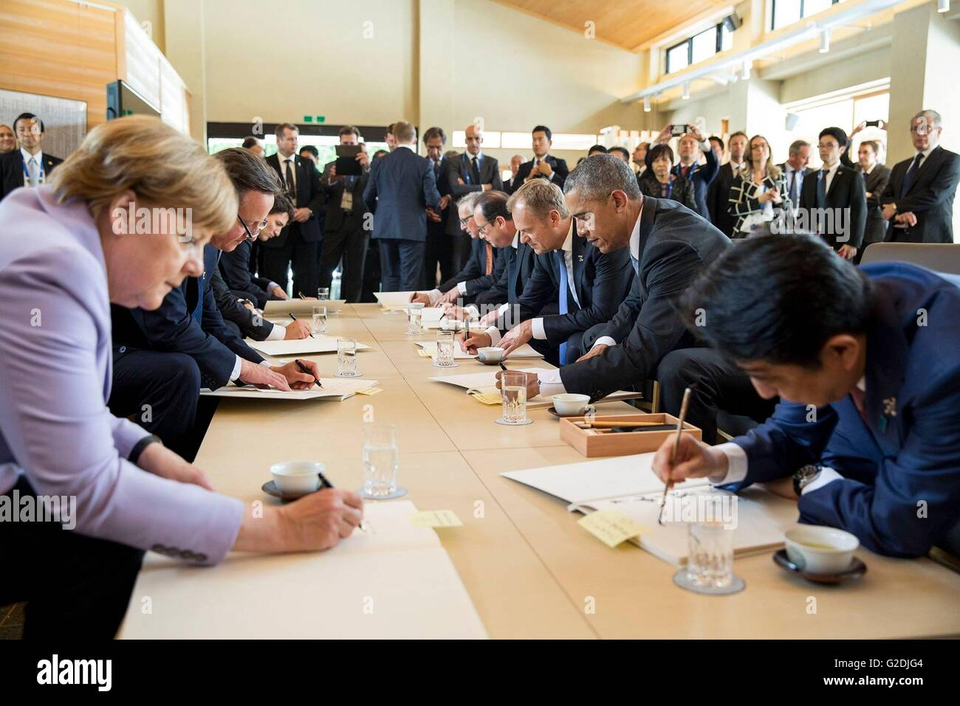  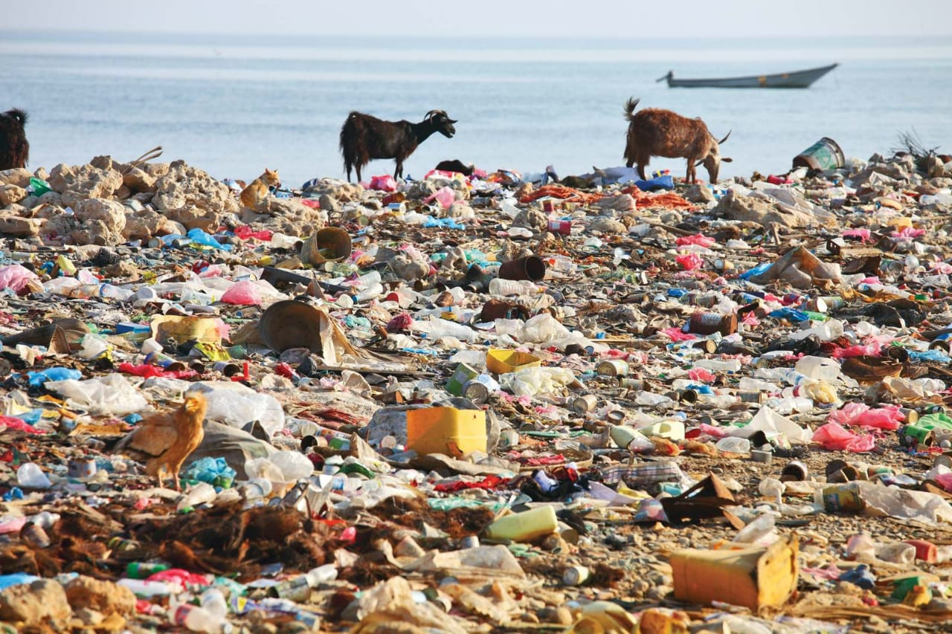 

‘A victory that feels like defeat’

FROM PAGE 1 Sabha, a much-needed recognition of the strength of the principal opposition party with national footprints and a far cry from BJP’s vision of a “Congress-mukt Bharat.” The result will also consolidate Congress’s pole position in the opposition alliance and allow it to control some regional allies like TMC. The principal opposition party banked on three factors to fight the election this time: the formation of INDIA bloc, its manifesto raising the bread and butter issues like inflation and joblessness, promising a slew of cash doles as well as appealing to caste groups and its sustained campaign to protect the Constitution to safeguard the reservation. Several factors are behind NDA’s result this year. Modi’s consistently pressing hard with a polarising narrative for much of the electioneering to counter his political rivals, the law of diminishing return of the consecration of the Ram temple in Ayodhya issue and the remarkable rise of INDIA, a loosely-crafted opposition alliance of 28 parties less than a year ago – all have played their parts. It also shows that every emotive issue, however appealing, has a shelf life and creates fatigue among voters if played repeatedly at the expense of other more pressing issues. The INDIA bloc made deep inroads in several politically crucial Hindi heartland states including Uttar Pradesh which sends the highest number of lawmakers to the Lok Sabha (80). The alliance has made steady headway in Rajasthan, Bihar, Haryana and Jharkhand. The Hindispeaking belt has 225 seats. In Uttar Pradesh, Akhilesh Yadav-led Samajwadi Party made a turnaround like a phoenix rising from the ashes.

No more structures in Rohingya camps: PM

Prime Minister Sheikh Hasina yesterday said the government will not allow new structures in Rohingya camps.

“It would not be wise to allow new structures in Rohingya camps in Cox’s Bazar as ecological imbalance has been caused due to massive deforestation,” she said. The PM said this while Japanese Special Envoy for National Reconciliation in Myanmar Yohei Sasakawa called on her at the Gono Bhaban. The PM’s speech writer Md Nazrul Islam briefed reporters afterwards. Hasina said if Rohingyas are taken to Bhashan Char, their quality of life will improve. She sought the Nippon Foundation chairman’s support for the repatriation Rohingyas to Myanmar. Yohei Sasakawa lauded the accommodation facilities of Rohingyas in Bhashan Char, and said that Nippon Foundation is keen to providing training to the Rohingyas to boost their income as well as education to Rohingya children.Khondaker Golam Moazzem, research director at the Centre for Policy Dialogue, said the main reason behind A Dhaka court yesterday sent Bashudeb Banerjee, an associate of PK Halder and the then director of International Leasing and Financial Services (ILFS), and his wife Papia Banerjee, also a director of the institution, to jail after rejecting their bail petitions in 14 money laundering cases. Prashanta Kumar Halder, known as PK Halder, a former managing director of NRB Global Bank, is reportedly involved in Tk 10,000 crore loan scam. He was arrested in Ashoknaga ndia on May 14, 2022. Judge Mohammad Ash-Shams Joglul Hossain of Dhaka Metropolitan Senior Special Judge’s Court passed the order after the couple surrendered before it, seeking bail in the cases, said ACC Public Prosecutor Mosharraf Hossain in 14 money laundering cases. Prashanta Kumar Halder, known as PK Halder, a former managing director of NRB Global Bank, is reportedly involved in Tk 10,000 crore loan scam.

REJAUL KARIM BYRON, ASIFUR RAHMAN

………………………………………

The subsidies and incentive expenditures in the upcoming budget are going to be more than that of the current fiscal year.

The subsidies are mainly increasing in the power, energy, and the agriculture sectors.

Even though the government plans to raise power tariffs four to five times a year, the highest subsidy allocation is likely to go towards the electricity sector.

Finance ministry officials said the increased subsidy allocation was largely due to the arrears in the power and agriculture sectors.

Of the sum to be set aside for 2024-25, the power sector is likely to get Tk 42,000 crore. The government has earmarked Tk 35,000 crore for 2023-24. Before 2021-22, the subsidy allocation for the power sector was between Tk 7,000 crore and Tk 9,000 crore.

Khondaker Golam Moazzem, research director at the Centre for Policy Dialogue, said the main reason behind the rising subsidy allocation in FY25 is the higher energy prices in the international market and elevated capacity payments.

He said the government has planned to increase power tariffs several times, but the sector will require more subsidies as more power plants, including Rooppur nuclear plant, are ready to produce electricity.

"If the old and inefficient power plants are not phased out, the overall capacity charges will increase, which will deepen the subsidy burden," he told The Daily Star.

The recent mission of the International Monetary Fund also questioned the huge subsidy allocation in the power sector.

The government usually provides subsidies to the export sector in the form of incentives to businesses. In the current fiscal year, Tk 9,025 crore was set aside, and it is likely to reduce to less than Tk 7,000 crore, according to the officials. In the case of senior citizens, a person will get Tk 600 per month and widows, deserted, or destitute women will get Tk 550 per month.

SEE PAGE 2 COL 3